Instructor: Alice Pedersen Librarians: Amanda Hornby, hornbya@uw.edu
Sharde Mills, eliza00671606@gmail.com

How to Find Book Reviews
Select one or two of the below recommended research resources. Search the resource using keywords from your “Short Paper Three” to find book reviews of Atonement.

Recommended Starting Point #1: Access World News
Linked from E-Newspapers and News, http://www.lib.washington.edu/types/enewspapers/
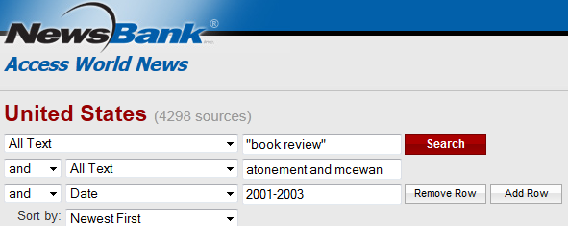
Limit by publication date
- Combine “book review” with keyword describing your topic, using AND
- Limit your search by publication date
- Email, save and cite your sources easily within Access World News

Recommended Starting Point #2: LexisNexis Academic
Linked from E-Newspapers and News, http://www.lib.washington.edu/types/enewspapers/

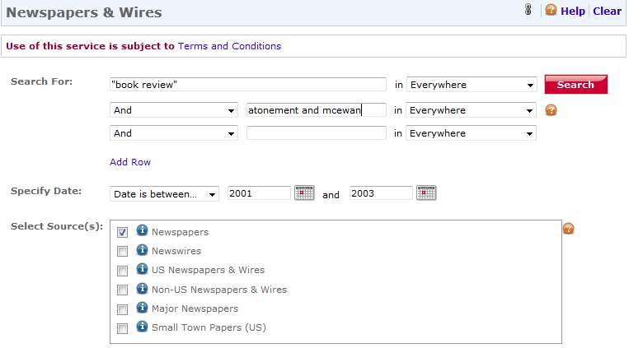
Keyword search using the term “book review”
Limit by publication date
- On the homepage of LexisNexis navigate to the left side column, select “News,” and then select “Newspapers and Wires”
- Combine “book review” with keywords describing your topic, using AND
- Limit your search by publication dates
- Email, save and cite your sources easily within LexisNexis

Recommended Starting Point #3: New York Book Review and Times Literary Supplement
Linked from the English Subject Guide, http://guides.lib.washington.edu/english

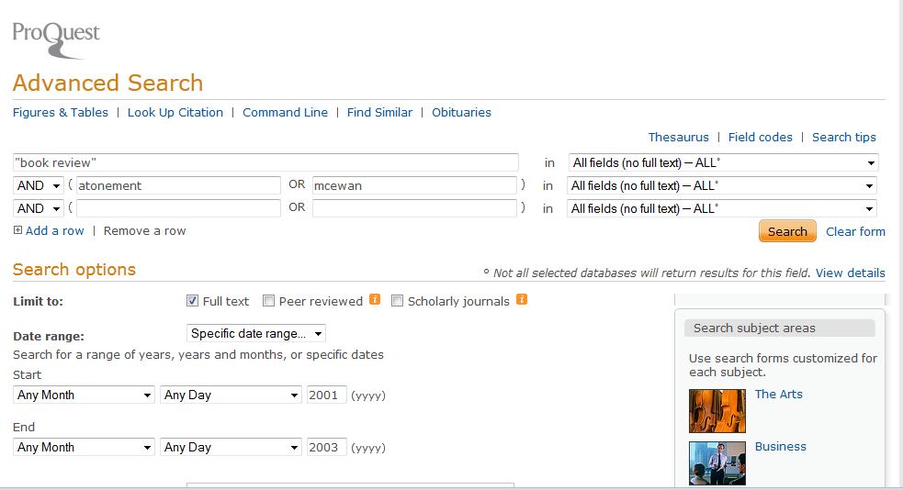
Specify Search Field
Only pull full text reviews

- Under the book review tab on the English subject page select “New York Book Review”
- Choose Advance Search
- Change the first line’s search field to “All fields (no full text)-ALL”
- Limit to Full Text
- Combine “book review” with keywords describing your topic, using AND
- Limit your search by publication dates
- Email, save and cite your sources easily within LexisNexis

After you have found book reviews, please cite (and save) at least two. For each source, write at least one sentence describing why you selected this article/source, and how it is relevant to your research topic.
Citation for Book Review #1:
Author:
Article Title:
Journal Title:
Volume, Issue#, Date:
Database Retrieved From:
Additional Descriptive Information / Notes:
Citation for Book Review #2:
Author:
Article Title:
Journal Title:
Volume, Issue#, Date:
Database Retrieved From:
Additional Descriptive Information /Notes:

Activity: Source and Author Evaluation, Credentials & Authority
Select one of the book reviews you found today and study it more carefully through research and deeper reading. Take special note of information that is new to you or that changes, shapes, or confirms your previous impressions of Atonement or the work of Ian McEwan.
After you read your book review, please respond to as many of the following questions as you can. These questions will help guide your reading and discussion and will prepare you for “short paper three.” Please be prepared to share your responses with the class.
Author evaluation:
- Who wrote your book review?

- Do some research about your book review author (via Google or a search engine). What is his or her area of expertise? What other types of articles, books, etc. has the author written? List any other relevant information you find about the author and his or her background here.

- Who is the intended audience for the book review? (For example: general audience, well-informed book readers, scholars, etc.) Does the author have a particular bias or point of view?

Source evaluation:
- In which newspaper was your book review published?

- Do some research about your newspaper (via the news database or Google). Where was your newspaper published? Where is your newspaper distributed (local, regional, national, international, etc.)? List any other relevant information you find about the newspaper here.

- Who is the intended audience for the newspaper? Does the newspaper have a particular bias or point of view?

- Does the book review indicate a favorable (positive) or critical (negative) reception of Atonement? How do you know this?

In small groups, share with your classmates your book review article and your responses to the above questions. Please be prepared to share your reflections with the class.
RESEARCH TIPS: Researching from off campus? Search article databases from off-campus locations or your laptop by logging in with the off-campus access button and your UW Net ID.
Need help? Chat with a librarian online 24/7: http://www.lib.washington.edu/about/contact
Citation help: http://guides.lib.washington.edu/citations

